Police Reserve Association
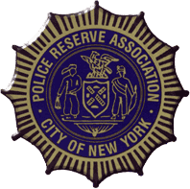
CUSTOM HONORARY MEMBER CARD ORDER FORM
You can order a card that looks like the one pictured on the right by completing this form. These cards cost $25.00 each and can be ordered for family members or close friends. Their name will appear on the front of the card where it says “NAME GOES HERE” and the caption underneath says “HONORARY MEMBER”. Cards may be ordered by mailing $25.00 per card requested. Please enclose your check made payable to: Police Reserve Association, City of NY, Inc. | 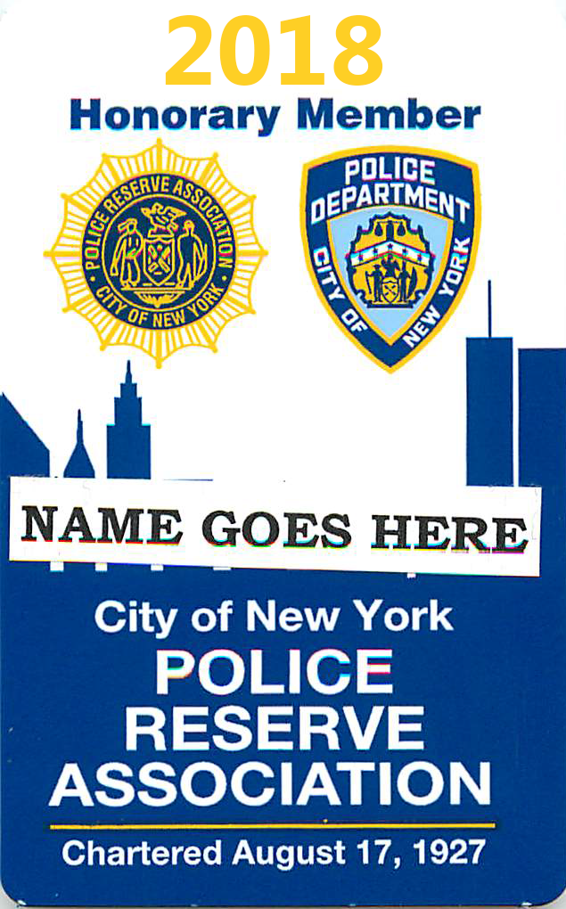

Your First Name ______________________Last Name ____________________________
Member ID #_____________________ Email Address: ____________________________
Your Signature ________________________________
HONORARY MEMBER’S NAME HONORARY MEMBER’S NAME
TO BE PRINTED ON CARD TO BE PRINTED ON CARD

1.__________________________ 7. ___________________________
2.__________________________ 8. ___________________________
3.__________________________ 9. ___________________________
4.__________________________ 10. __________________________
5.__________________________ 11. __________________________
6.__________________________ 12. __________________________

New York City Police Reserve Association
45 Broadway, 31st Floor,
New York, NY 10006
Tel: (212) 564-0010
Email: nycprapres@gmail.com

